Contractor: |  | Owner of Plant/Hirer:
Manufacturer: |  | Model Number:
Serial Number: |  | Date Manufactured:
Date of Annual / CraneSafe / Inspection:  (within 12 months) |  | Road Registration:
Last Serviced: |  | Date On-site:
Next Service: | 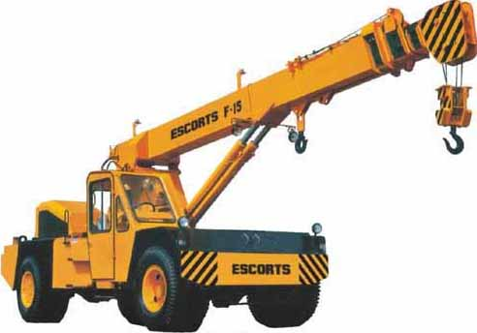

Documentation Checklist

Operator’s manual
Log book (Pre-start Daily Checks)
Maintenance records
(refer to operator’s manual for service intervals)
Certification of Major inspections - 10 year + 25 year
(if applicable)
Current Road Registration (if driven on public roads)
Current Drivers License if applicable
Regulator Plant Registration Certificate (if over 10 ton SWL)
Plant Risk assessment, compliant with S08-04-35 Plant and Equipment
NDT test records (12 monthly testing)
Test Certificate for main wire rope and annual test certificates for chains and lifting equipment
(12 monthly testing)
Load charts (refer to operators manual)
High Risk Licence for Operator - "CN" or "C2"or “C6” or "C1" or "CO" (depending on cranes capacity)

Visual Inspection Checklist

Compliance/lD plates fitted to machine
Load charts fitted in cabin
Seat belt fitted
Reverse beeper functioning and audible
Flashing light functioning
Fire extinguisher fitted
Anti-two-blocking device functioning if fitted
Tyres properly inflated and in good condition
Check housekeeping in cabin - neat and tidy
All controls and instruments clearly labelled, marked and operating including lights, horn, brakes etc
No obvious signs of oil leaks to any components
No obvious signs of damage, such as cracked, broken, bent, rusted, missing components
All chains fitted with tags identifying SWL's, serial numbers and test dates
All other lifting equipment should have SWL's, serial numbers and test dates clearly marked.
External safe load indicator (Christmas Tree Lights) functioning - if fitted

